Grade 7 Accelerated · Unit 4 · Lessons 7–8  Real-World Order of Operations  Independent Set 4.07 ANSWER KEY | Name  Date  Period

Six questions, on your own, in silence. Show the step that does the work.
1. 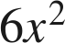 when 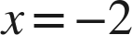
24
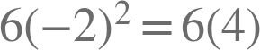.

2.  when  and 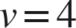
720
.

3. 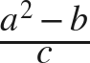 when 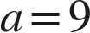, 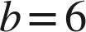, 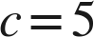
15
Finish the numerator first: .

4. A square room of side 10 feet is carpeted at 2.65 dollars a square foot, with a flat 55 dollars for fitting. Find the total cost.
320 dollars
.

5. 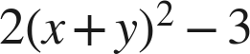 when  and 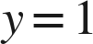
47
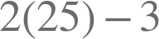.

6. A gym charges 25 dollars to join plus 8 dollars for each of 6 classes. Find the total cost.
73 dollars
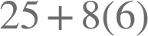 — only the class price is repeated.

